1. The number of absentees in class VIII was recorded in a particular week. Represent this data on
the bar graph
(i) Create a line graph with appropriate Labels and title
(ii) Use blue line color with style dotted
(iii) Points represented in yellow color and diamond shape
Days | Mon. | tues | wed | thur | fri | sat
Number of Absentees | 130 | 120 | 135 | 130 | 150 | 80

PROGRAM
import matplotlib.pyplot as plt
import numpy as np
xpoints = np.array(['mon', 'tue', 'wed', 'thur','fri'])
ypoints = np.array([400, 500, 350, 300,500])
plt.xlabel("Days")
plt.ylabel("number of absenties")
plt.plot(xpoints, ypoints,'Dy',ms = 20)
plt.plot(xpoints, ypoints, ':b')
plt.show()

OUTPUT
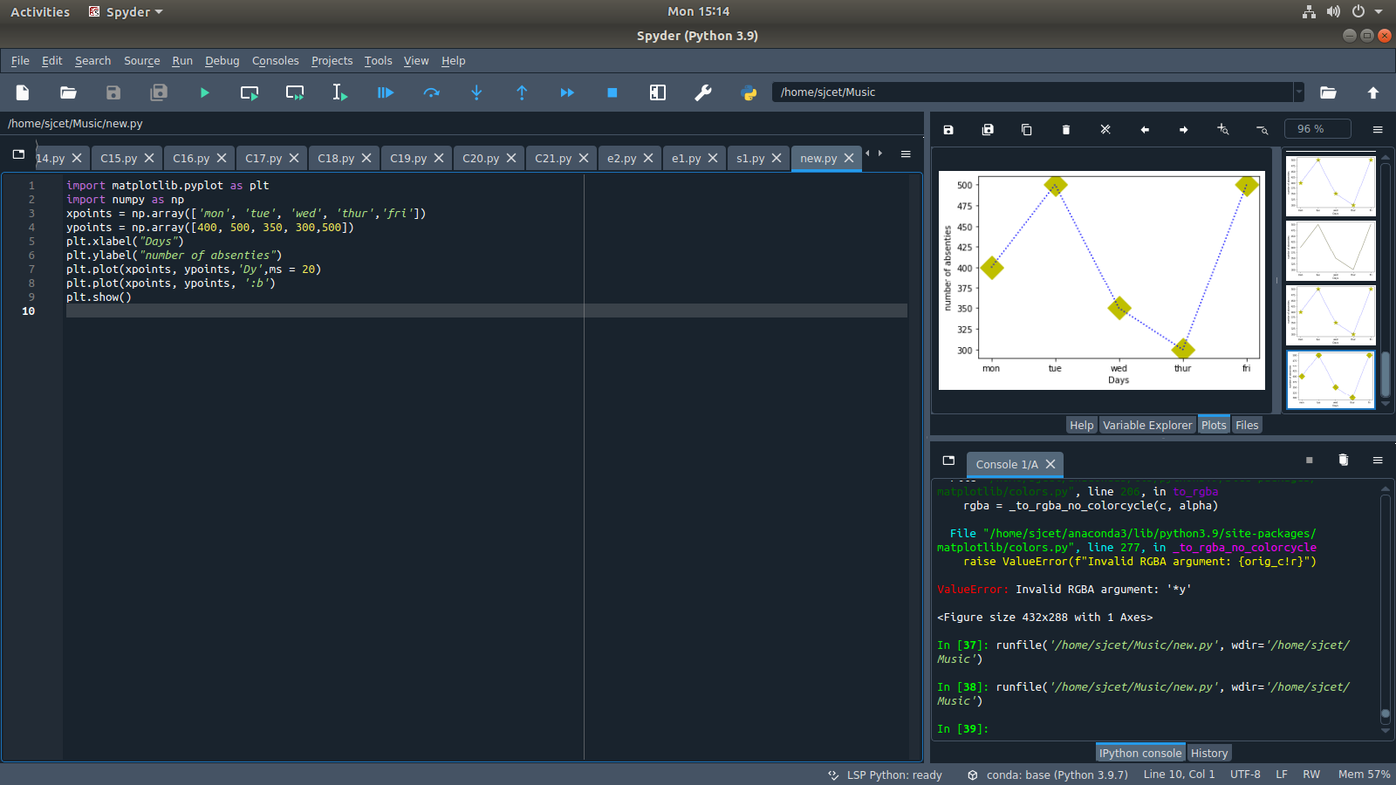

2. Program to print first n prime numbers
PROGRAM
numr=int(input("Enter range:"))

print("Prime numbers:",end=' ')

for n in range(1,numr):

for i in range(2,n):

if(n%i==0):

break

else:

print(n,end=' ')

OUTPUT
